Solution Architecture
Date | 10-07-2026
Team ID
Project Name | RK Health AI – Smart Healthcare Management System
Maximum Marks | 5 Marks

Solution Architecture Diagram
RK Health AI follows a layered architecture where the React + Vite frontend communicates with a Google Apps Script backend through a unified API layer. The backend stores data in Google Sheets and integrates with Twilio SMS, Groq AI and Google Calendar.
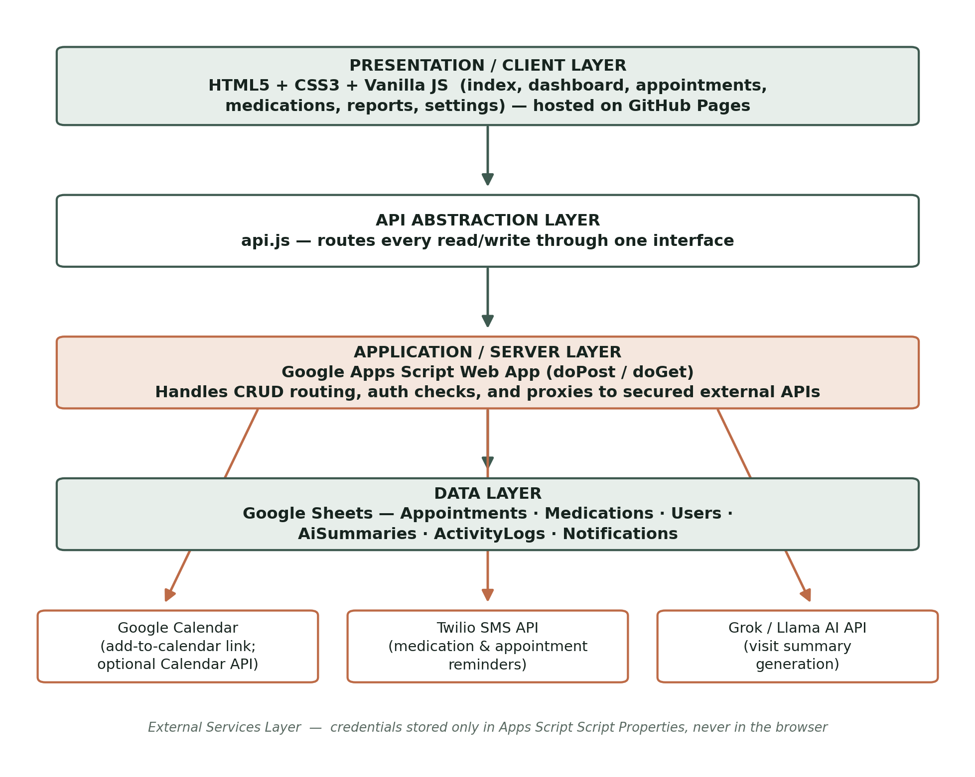

Component Description Table
Component Name | Description / Role in Architecture | Technologies Used
Presentation Layer | Provides responsive healthcare dashboard, patient, appointment, medication, reports and settings modules. | React.js, Vite, HTML5, CSS3
API Abstraction Layer | Centralized api.js handles communication between frontend and Google Apps Script. | Fetch API, JavaScript
Application / Server Layer | Processes CRUD requests, AI summaries, SMS notifications and Calendar integration. | Google Apps Script, UrlFetchApp
Data Layer | Stores Patients, Appointments, Medications and AI summaries. | Google Sheets
External Services | Provides SMS, AI health summary and calendar scheduling. | Twilio API, Groq AI API, Google Calendar API

